Name: ___________________________
8th FACS Recipe Book

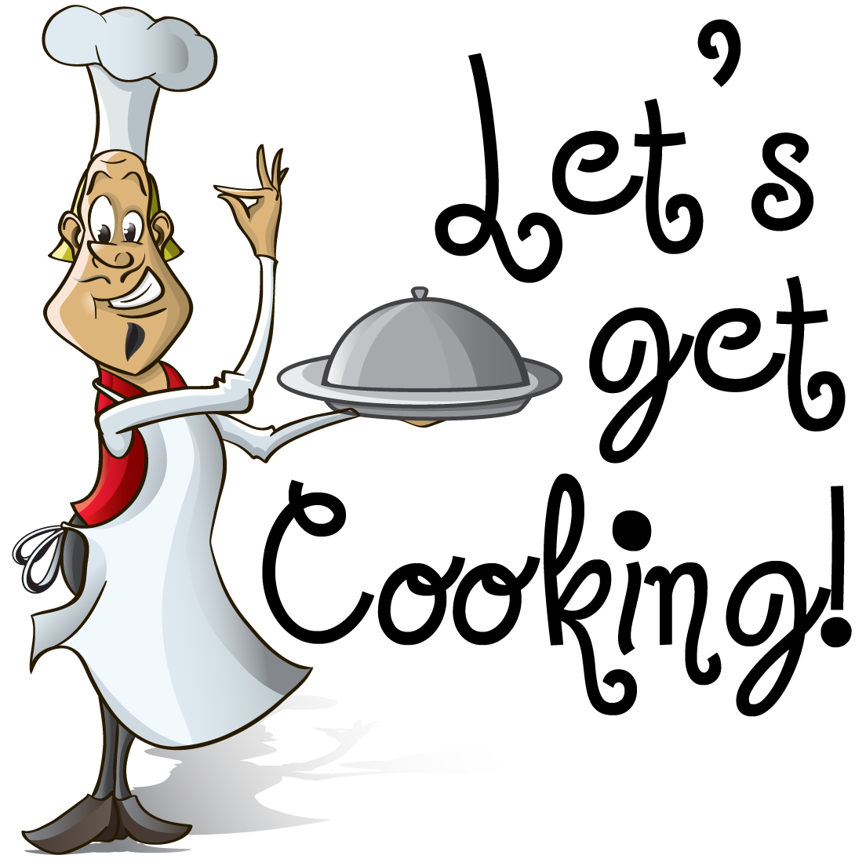

Hurricane Middle School
FACS Exploration
NOTE: Each Lab worth 30 points & Lab Evaluations worth 84 pts
Quick! Hand me the Whatchmacallit!
Goal: To locate all items to be used and stored in our kitchens
Directions: Mark the cupboard or drawer number where this is found so you know where to return it after it’s used.
Pizza Pan #_______ Pastry Brush #______
Cutting Boards #_______ Dry Measuring cups #_______
Turners #_______ Liquid Measuring cups #______
Muffin Tin #_______ Rubber Spatula #_______
Dinner Plates #_______ Rolling Pin #_______
Biscuit Cutter #_______ Skillets #_______
Bosch Mixer #_______ Electric Hand Mixer #_______
Chef Knives #_______ Cereal Bowls #_______
Mixing Bowls #_______ Straight edge Spatula #______
Whisk #_______ Can Opener #_______
Cookie Sheet #_______ Silverware #_______
Pizza Cutter #_______ Square Glass pan #_______
Tongs #_______ Serving Bowls #_______
Apple corer #_______ Drinking cups #_______
Egg Separator #_______ Kitchen Shears #_______
Pots & saucepan #_______ BlendTec Blender #_______
Pastry Blender #_______ Hot Pads #_______
Dish Soap #_______ Custard Cups #_______
Red Tray #_______ Dish Towels/Rags #_______
Garbage Cans #_______ Aprons #_______
Brooms #_______ Silverware #_______

Oatmeal Chocolate Chip Cookies

Directions: Preheat oven to 350 degrees. Mix the first 5 ingredients together. Then, add remaining ingredients and mix to make cookie dough. Last, use portion scoop to place dough on a baking sheet. Bake for 8-10 minutes.
- ½ cup margarine
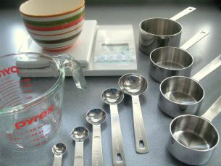
- ½ cup brown sugar
- ½ cup white sugar
- 1 egg
- ½ teaspoon vanilla

- 1 ¼ cup flour
- ½ teaspoon baking powder
- ½ teaspoon baking soda
- ¼ teaspoon salt
- 1 cup oatmeal
- ½ cup chocolate chips

Measurement LAB EVALUATION- 10 pts
- How many seconds do you wash your hands before preparing food? _______

- List the four sizes of measuring spoons we discussed and place them in order from largest to smallest. ______ ______ ______ ______

- List the four sizes of dry measuring cups we discussed and place them in order from largest to smallest. ______ ______ ______ ______

- How many cups are in a cube of butter? ________

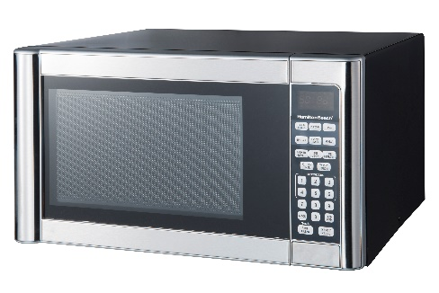
Microwave Bubble Bread
Ingredients:
1/3 cup brown sugar 1 Tablespoon water
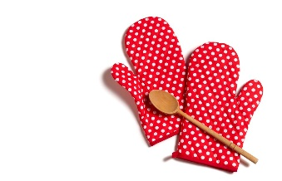
3 Tablespoons Margarine 1 can refrigerated biscuits

Directions:
- Using a pizza cutter, cut each of the biscuits into fourths
- In the square baking dish, combine brown sugar, margarine, and water together and then microwave for 1 minute.
- Now, place the biscuit pieces on top of the melted brown sugar mixture and microwave for 2 minutes or until they are not sticky. (No more than 3 min)
- Remove the dish from the microwave WITH HOT PADS, IT WILL BE HOT!
- To serve, place a large serving plate on top of the casserole dish and turn it upside down until the bread comes out.
- Pull apart with fingers and Enjoy!

Bubble Bread LAB EVALUATION- 10 pts
- What is the proper piece of equipment used to measure milk?

- What piece of equipment would you use to cut-in?

- Which two ingredients do you use to CREAM? __________ ___________

- Which piece of equipment would you use to dice, mince, or chop? _________

- To sauté, you would use a small amount of ___________ with your veggies.

- What are the abbreviations for the following words?

Package ______ Tablespoon _______ Quart ______ Ounce _______

Fruit Smoothie
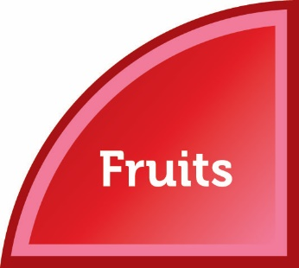
Ingredients:
1 ¼ c 100% Orange Juice 1 c frozen berries
½ can pineapple chunks 1 banana

Directions:
Pour orange juice into the blender and then add the fruits. Push the smoothie button. If there are large chunks, push the pulse button a couple of times. Serve each group member and Enjoy!

SMOOTHIE LAB EVALUATION- 17 pts

- List 2 reasons we discussed to buy fruits in season?

- Recommended FRUIT servings per day for Boys: ________ Girls: ________

- Eating our servings of fruit can help prevent 5 chronic diseases. List 3 of them: _________________ _______________ ________________

- Fruits are high in which 3 nutrients:

_______________ _____________ ________________
- How would you HALF the following ingredients:
1 ½ c flour ___________ ¼ c sugar ___________
½ tsp salt ___________ 2 cups milk __________

- To get your fruit servings, list the ways you can eat fruits.
Fresh, __________, __________, dehydrated, ____________

Jalapeño Cheese & Corn Muffins - Even Group #’s

1 Jalapeño ½ cup buttermilk
1/3 c sugar ¼ tsp salt
1 Tbsp. honey ½ c yellow cornmeal
¼ c melted butter ½ c flour
1 egg ¼ c shredded cheddar cheese
¼ tsp baking soda 1 glove & 10 cupcake papers
Directions:
- Preheat oven to 375°. Using the glove, remove the seeds from the jalapeño and chop it into very small pieces. Then set it aside.
- In a medium bowl, stir sugar, honey, and butter together. Whisk in the egg, baking soda, and buttermilk.
- Add salt, cornmeal, and flour and mix everything together. Do not over mix. (As soon as the flour disappears you should stop mixing)
- Fold in the jalapeño and shredded cheese.
- In your lined muffin tin add equal amounts of batter into 10 of the cups.
- Bake for 15-20 minutes.

De-Lish Cornbread Muffins - Odd Group #’s
1/3 c flour ¼ tsp salt
¼ c yellow cornmeal 3 Tbsp. Vegetable oil
1 egg 1 1/3 c yellow cake mix
2 T sugar ½ c milk
1 ½ tsp baking powder 10 cupcake papers
Directions:
Preheat oven to 350°. Combine all dry ingredients in a mixing bowl and mix well. In a separate mixing bowl combine oil, milk, & egg together. Combine the two mixtures and stir until batter is smooth. Put batter into 10 lined muffin cups and bake for 15-20 minutes.

Cornbread LAB EVALUATION- 16 pts
- List 4 examples of whole grains: ____________, _____________, _____________, _______________

- What are refined grains according to our discussion in class?

- List 3 examples of refined grains discussed in class?
___________________ _________________ ________________

- What is the key consumer message for grains that we want you to know?

- List 3 nutrients you get from eating grains.
________________ _________________ __________________

- List 2 ways you could get more whole grains in your diet.
__________________________ __________________________

- What does it mean if your bread or food label says it is enriched? _________________________________________________________

- Grains contain carbohydrates which give your body ________________.

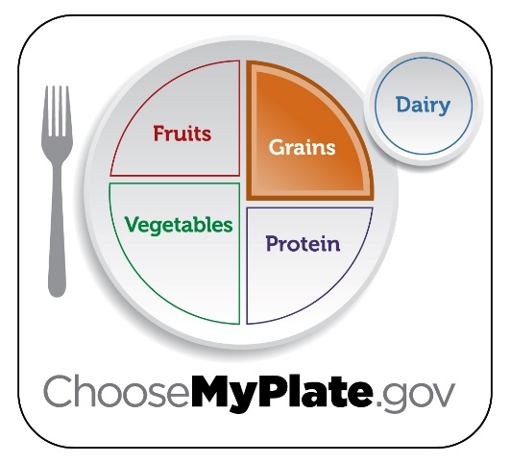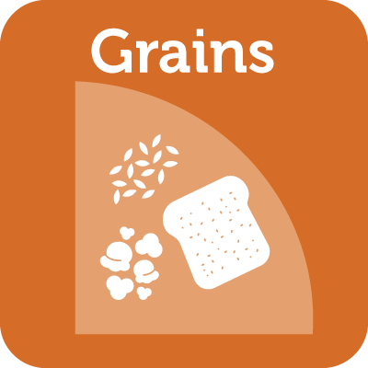

Italian Cheese Bread

Dough Ingredients Topping Ingredients
2 ½ C flour ¼ C Italian dressing
1 tsp salt ¼ tsp salt
1 tsp sugar ¼ tsp garlic powder
1 T Yeast + 1 T sugar ½ tsp Italian seasoning
1 C warm water 1 T grated parmesan cheese
1 T vegetable oil 1 slice mozzarella cheese
Directions:
- Preheat oven to 450°.
- In the 2 cup liquid measuring cup add the warm water, yeast, and 1 T sugar. **Stir ingredients just enough to incorporate them and let sit for 5 minutes to activate the yeast. It should look cloudy and foamy.
- Put flour and salt into the Bosch mixing bowl (with dough hook attached) and turn it on to 1.
- After the 5 minutes, add oil to the active yeast mixture.
- With the lid on the mixing bowl, gradually add the liquid to the dry ingredients and change the dial to 2. This will speed it up a little bit.
- When the dough starts to pull away from the sides of the bowl and a dough ball forms, turn the speed up to 3 and “knead” it for 3 minutes. It is normal for the machine to be rockin’ a bit.
- After it’s kneaded, allow the dough to rest and rise for 8-10 minutes.
- After rising, punch the dough down and place it on a greased pizza pan. Push the dough with your hands out to the edges to look like a pizza dough.
- With a pastry brush, coat the dough with the Italian salad dressing. Then, sprinkle the rest of the topping ingredients over the surface of it.
- Put the pan in the oven and bake for 15 minutes or until it is golden brown. Remove it from the oven and cut pieces with the pizza cutter and Enjoy!

Fettuccine Alfredo
Job #1 Pasta
Pick up a quarter-sized bunch of noodles from the supply table. In a large saucepan boil water. Add pasta to boiling water and allow to boil for 10-12 minutes.
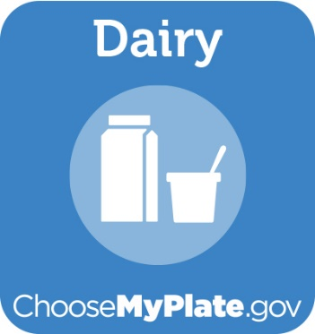
Job #2 Alfredo Sauce
Pick up ingredients from the supply table:

3 oz cream cheese ¾ C evaporated milk
1 T butter ¼ C parmesan cheese
¼ tsp garlic powder

Melt butter and cream cheese in a saucepan on medium heat, stirring often. Whisk in evaporated milk and garlic powder then stir constantly until sauce has thickened. Last, add Parmesan cheese. Stir well and serve over pasta with broccoli.
Job #3 Broccoli
Wash broccoli, then cut it into bite-sized pieces and place it in your round glass dish. Add 1/4 C. water and cook in the microwave for 3 ½ minutes with the lid on. After it’s cooked, drain the water off and keep warm until ready to serve.
When all three items are ready, serve each group member and enjoy!
DAIRY LAB EVALUATION- 8 pts
- What is the key consumer message of the dairy group? Did we do that today in our recipe?

- What is the MAJOR health benefit of consuming dairy products?

- Which age of life is it when consuming adequate dairy is important?

- Milk is the most _________________ drink you can drink.

- List 2 foods NOT considered dairy because of the high fat content.

- Besides calcium, which other 2 vitamins do you get from drinking milk?
Tasty Vegetable Tray
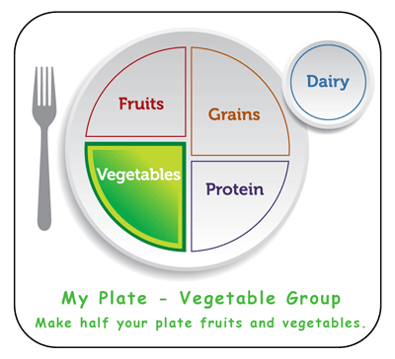
1 pepper
1 cucumber
5-10 cherry tomatoes
15 baby carrots
2 celery stalks
10 black olives
Or any other awesome in-season veggies your teacher has :o)

With your group, cut up each ingredient and create an appetizing and fun vegetable tray. After each group has finished cutting and making their design, you can pick up ranch dip from your teacher to use for dip. Enjoy!

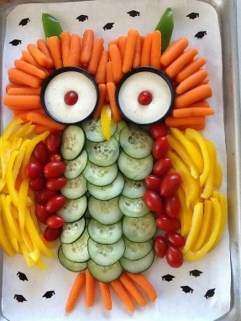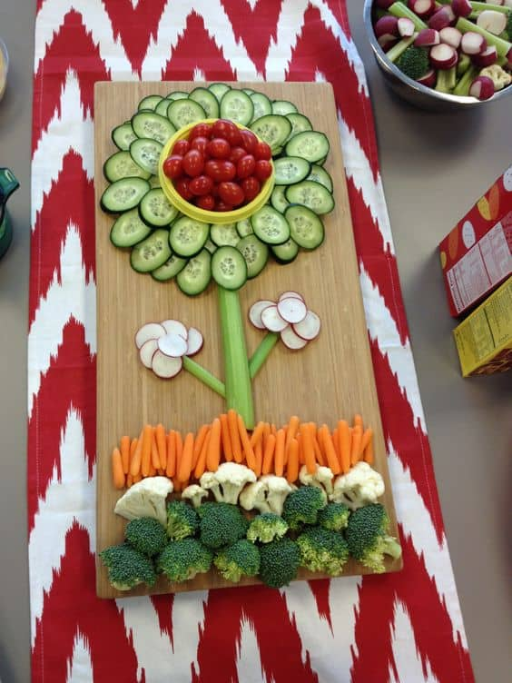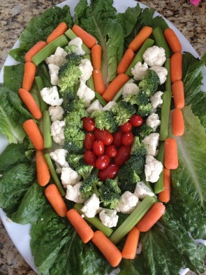

VEGGIE TRAY LAB EVALUATION- 7 pts

- Vegetables contain no added _____________ or ______________.

- Vegetables are HIGH in which 2 nutrients? ___________ & _________.

- Which colors of veggies have more nutrients?

- Which color of nutrients would likely have the LEAST amount of nutrients?

- How should you hold your non-cutting hand when you’re cutting veggies?
Quinoa Cups
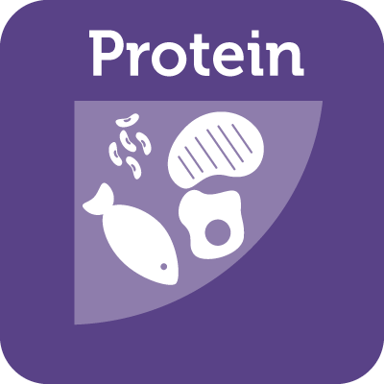
1 cup cooked Quinoa 1 egg
¼ C grated zucchini 1 egg white
1 block of cheese to grate 2 slices of ham diced
2 sprigs of parsley minced 1 T Parmesan cheese
1 green onion chopped ¼ tsp salt
¼ tsp pepper

Directions:
- Place your muffin tin in the oven and preheat to 400° (DON’T spray with cooking spray yet).
- Add all above ingredients into a large mixing bowl and combine together. Please make sure the excess egg is put into the trash
- Carefully remove the pan from the oven with hot pads and quickly spray it with cooking spray. Spoon in the quinoa mixture filling the cups ¾ full.
- Bake 15-20 minutes or until the edges are golden brown.
- Remove from oven and let cool for 3-5 minutes. Enjoy! Yes you must try it :o)

Quinoa Cups LAB EVALUATION- 10 pts
- Protein foods come from which 2 sources?

- What is the key consumer message for proteins?

- Circle ALL of the foods below which contain protein:

Kidney beans chicken breast slice of bread pork chop

Salmon eggs almonds oatmeal hamburger patty

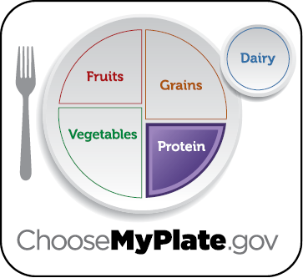
Sticky Chicken with Rice

¼ C cornstarch 1 chicken breast
½ C Russian dressing 2 T vegetable oil
¼ C apricot jam
Directions for chicken:
Preheat oven to 350°. Cut chicken breast into 1 inch squares then dredge or heavily coat them in the cornstarch. Place them in your large skillet with 2 T oil. Cook until they are lightly browned. Put them in your glass baking dish.
In a small mixing bowl, stir Russian dressing and jam together and pour over the chicken in the baking dish until all pieces are covered. Bake for 15 minutes.
Directions for Rice:
½ C white rice
1 ½ C water
In a saucepan, place rice and water together and bring to a boil with the lid on. Boil for 3 minutes then turn the heat down to simmer (about a 3) and cook for 10-12 minutes longer or until the water is absorbed.
Brown Rice: Your teacher has ½ cup of cooked brown rice which you should obtain and mix into your white rice once it is finished cooking.
After all ingredients are cooked, serve each group member and enjoy!

Chicken & Rice LAB EVALUATION- 8 pts

- Which rice is better for you that we ate today? Why is it?

- List 3 ways you can cook meats to make them lean.

- List 3 ways to vary your proteins:

- What was your favorite lab and why?
Lab Make-up Sheet

Option 1: If you miss a lab day during our FACS food and nutrition unit you can make up the assignment/points by making the recipe at home and getting a signature from your parents on the space below.
Option 2: You may also make the recipe and take a picture of it and show it to me or email a picture of YOU making it and get full credit after showing your teacher.

Food Item prepared: _______________________
- Did the recipe turn out the way you thought it should? Yes No

- Did you complete the lab evaluation? Yes No

- List at least 2 things you learned from preparing this recipe:

___________________________ _________________________
Parent Signature: ____________________________________

Food Item prepared: _______________________
- Did the recipe turn out the way you thought it should? Yes No

- Did you complete the lab evaluation? Yes No

- List at least 2 things you learned from preparing this recipe:

___________________________ _________________________
Parent Signature: ____________________________________

Lab Evaluation Grading Sheet

Oatmeal Cookies/ Measurement Lab…………………………………….._______/10pts.
Bubble Bread Lab…………………………………………………………………….._______/10 pts.
Fruit Smoothie Lab…………………………………………………………………._______/17 pts.
Cornbread Muffin Lab……………………………………………………………._______/16 pts.
Dairy Lab…………………………………………………………………………………..________/8 pts.
Tasty Vegetable Lab………………………………………………………………________/7 pts.
Quinoa Cups Lab………………………………………………………………………________/10 pts.
Chicken & Rice Lab………………………………………………………………….________/8 pts.

Total Points……………………………………………………………………………….________/86 pts.

